**Assignment 3- Complete the Task 1 Assignment below and return it before the deadline.**

**ONLY use MS Word Doc!!!**

**Adjectives and nouns**

You can describe changes using adjective and nouns. Most of the vocabulary is the same, but you need to learn the adjective and noun forms.

*There was****a considerable rise****in the income of Amandine Bakery.*

*The income of Amandine Bakery****saw/experienced/witnessed a considerable rise****.*

**You should spend about 20 minutes on this task.**

***The graph shows data about the annual earnings of three bakeries in Calgary, 2000-2010.***

***Summarise the information by selecting and reporting the main features, and make comparisons where relevant.***

Write at least 150 words.

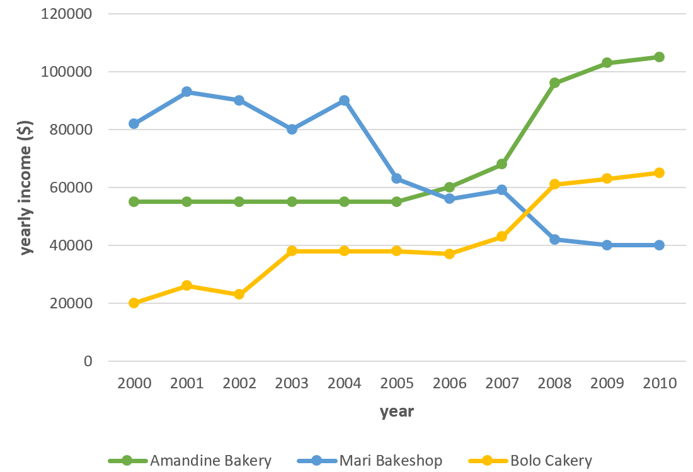

          The graph shows the yearly income of three bakeries in Calgary between 2000 and 2010. Obviously, two of them, Amandine Bakery and Bolo Cakery, witnessed a considerable rise. However, Mari Bakeshop is the only one that varied and resulted in a decrease.

          To begin with, both Amandine Bakery and Bolo Cakery experienced a noticeable rise. The annual earnings of the former one were stable and kept at the same level from 2000 to 2005, but started increasing in 2005 from 58000 to 120000 and even surpassed the income of Mari Bakeshop in 2006, consequently. Concerning the latter, the circumstances remained the same, gradually increased from 20000 to 62000 overall, fluctuated about 39000 between 2003 and 2006, slightly decreased in 2002, and exceeded the earnings of Mari Bakeshop as well.

          Furthermore, Mari Bakeshop is the only one that waved in the period; although it increased in some specific years, it decreased from 81000 to 40000 overall. In comparison, at the end, Amandine Bakery earned the most of all, followed by Bolo Cakery, and Mari Bakeshop took the last place.